SWT ROSETTA
RESERVATION FORM
I undersign Mr. / Mrs. ____________________, would like to confirm the following room reservation:
Date in: Date out:
Room in Single occupancy in B&B Basis (1 pers.): 99€TTC / night
Room in Double occupancy in B&B Basis (2 pers.): 113€TTC / night
(Type of Bed : DOUBLE BED TWINBED )
+ City Tax: 2.3€ / pers. / night
In order to confirm my booking, I authorize the hotel to charge the deposit on the credit card below. The amount of the deposit is 100% of the total amount of my reservation: __________€:
Type:
N°:
Expiration date:
Cryptogram:

This reservation is non-cancellable and nonrefundable. The reservation must be pre-paid of 100% on the confirmation day. The 100% deposit is nonrefundable.
Without this form duly filled-up and sign, the hotel do not guaranty the reservation of your room.
AT :
DATE :
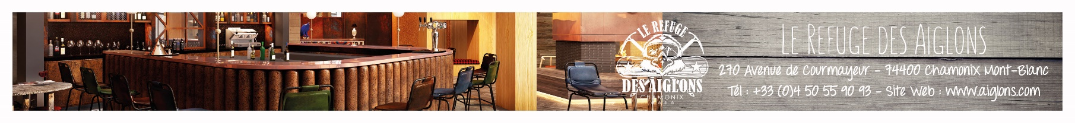
SIGNATURE :

